Senior Infants Class Booklist 2020/2021
English
Word Wizard Senior Infants  Gill Education | 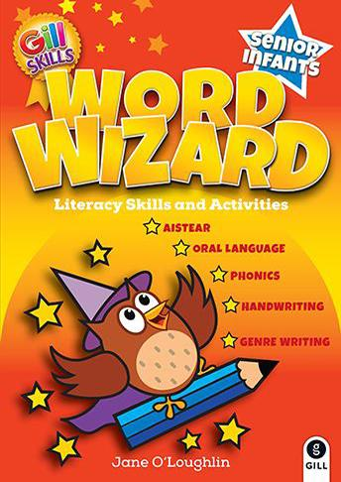
Go with the Flow Handwriting Book B  CJ Fallon | 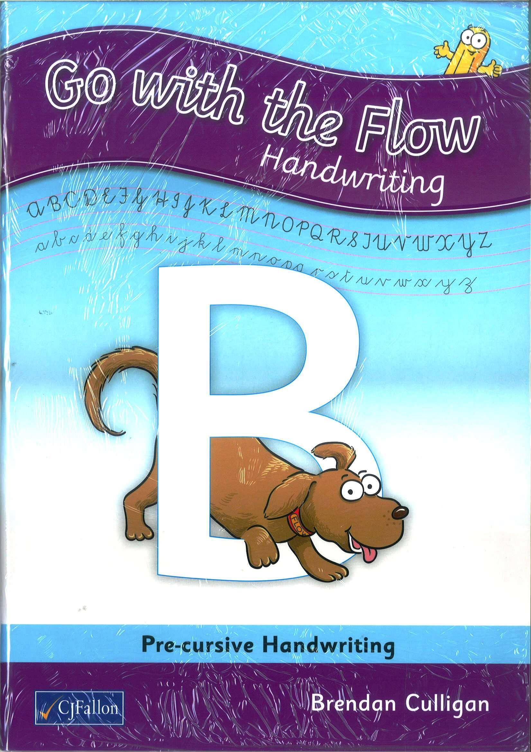
Jolly Phonics Pupil Book 2  Jolly Learning ltd | 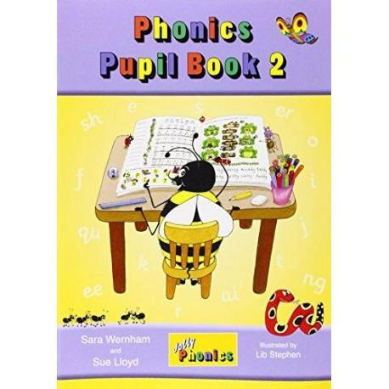
Maths
Operation Maths Senior Infants – Class Pack  (At School Book, At Home Book, Assessment Book, Mini-Whiteboard & 10 frame)  Edco | 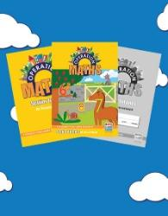

Copies and other

6 x Project Copybook Aisling (Purple) (15)

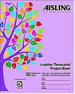
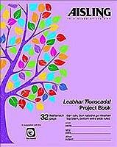

(Copies for: Gaeilge, free writing, SESE, homework and genre writing x2)

2 x Practice Copybooks Aisling (Light Blue, 32 pages, NO LINES)
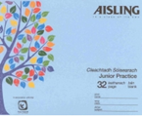
(Copies for: Aistear)

1 x Handwriting: Learn and Write B2
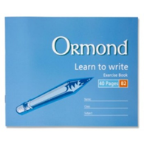

1 x Junior Sum Copy 20mm squares
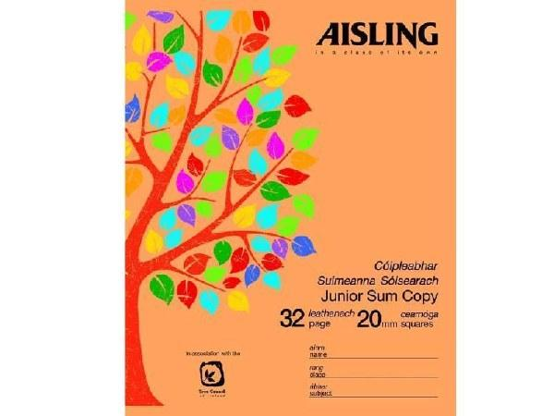

Please ensure that your child has each of the following at all times throughout the year:

- 3x HB Junior triangular Pencils
- 1 x large pencil sharpener
- 2 x erasers
- 3 x large Pritt Sticks
- Pack of large, thick crayons (Chublets)
- A4 (mesh type) Handy Pouch homework folder (pouch with zip)
- 3 x whiteboard markers (bullet tip)
- 1 x tub of ‘Play-Doh’
- 1 x A5 folder (mesh type with zip)
- Full change of clothes. All items must be labelled with child’s name.
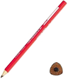
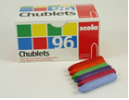

All senior infants families must sign up to use the DOJO communication system. This is used similar to a journal.

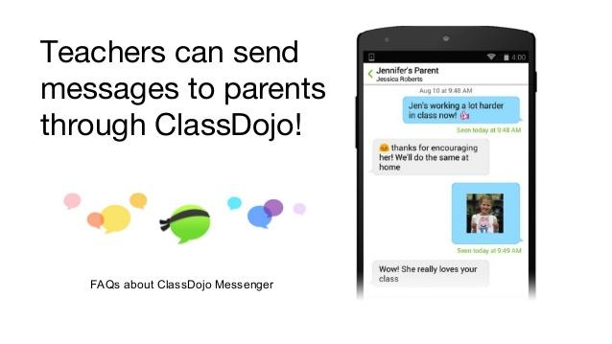
You can sign up in September 2020.

Please Parents/Guardians must purchase all text book and the correct copies and stationary items.
- Please cover all books and copies and put your child’s name on them.
- Please ensure that your child’s schoolbag is big enough to fit an A4 book in it.
- Please ensure that your child has all of the above on the first day of school as school texts will not be photocopied.
- All class booklists will be available on the school website: www.scoilchormaiccns.ie & photographs of the books & copies & stationary are available on the school website.
- The two bookshops in Balbriggan have been provided with a copy of the school booklists.

