Junior Infants Class Booklist 2020/2021
English
Just Phonics - Junior Infants 1 (26 Letters)  educate.ie | 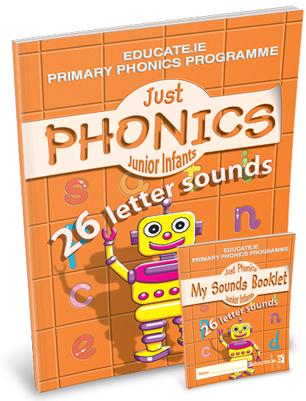
Just Handwriting: Cursive  Mini book included  education.ie | 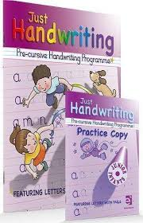
Maths
Operation Maths Junior Infants – Class Pack  (At School Book, At Home Book, Assessment Book, Mini-Whiteboard & 5 frame)  Edco | 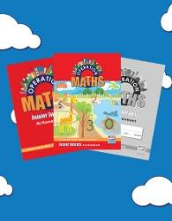

Copies and other

Project Copybook Aisling (Purple) (15)

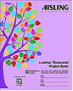

(Copy for: handwriting and genre writing)

5 x Practice Copybooks Aisling (Light Blue, 32 pages, NO LINES)
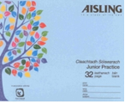
(

Copies for: Aistear, Gaeilge, and maths)

1 x Handwriting: Learn and Write B2
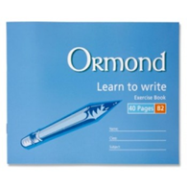

2 x A3 Scrap Book
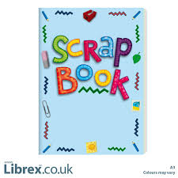

Please ensure that your child has each of the following at all times throughout the year:

- 3x HB Junior triangular Pencils
- Pencil sharpener
- Eraser
- 3 x large Pritt Sticks
- 2 x Tube of Playdough ( Play - Doh)
- Pack of large, thick crayons (Chublets)
- A4 (mesh type) Handy Pouch homework folder (pouch with zip)
- 3 x whiteboard markers (bullet tip)
- Full change of clothes. All items must be labelled with child’s name.
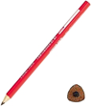
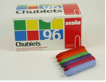
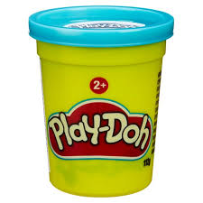

All junior infants families must sign up to use the DOJO communication system. This is used similar to a journal.

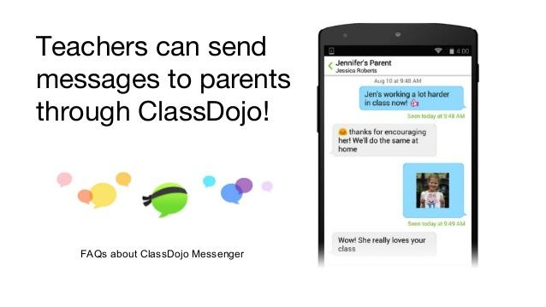
You can sign up in September 2019.

Please Parents/Guardians must purchase all text book and the correct copies and stationary items.
- Please cover all books and copies and put your child’s name on them.
- Please ensure that your child’s schoolbag is big enough to fit an A4 book in it.
- Please ensure that your child has all of the above on the first day of school as school texts will not be photocopied.
- If possible please get your child Velcro shoes.
- All class booklists will be available on the school website: www.scoilchormaiccns.ie & photographs of the books & copies & stationary are available on the school website.
- The two bookshops in Balbriggan have been provided with a copy of the school booklists.

