Fourth Class Booklist 2020/2021
English
Word Wizard 4th Class  Gill Education | 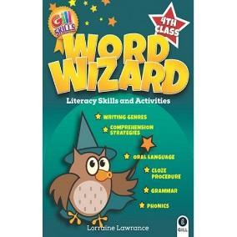
Go with the Flow Handwriting Book F  CJ Fallon | 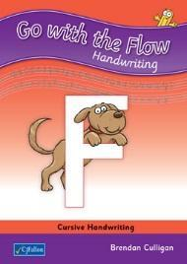
Collins Pocket English Dictionary & Thesaurus  Collins  Dictionary will be used by your child until 6th class | 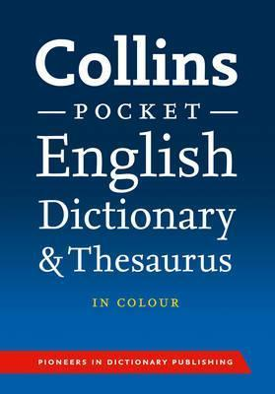
Maths
Operation Maths - Discovery Book 4, Assessment Book 4, Mini whiteboard and Place Value Card  Edco | 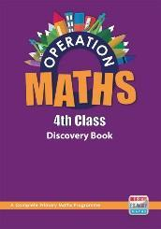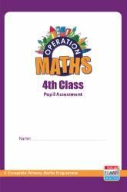
Maths Time 4  Edco | 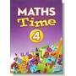
Tables Champion for 4th class  Educate.ie | 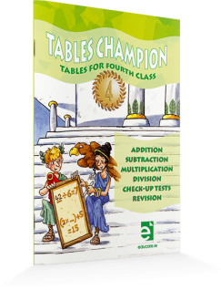

Gaeilge
Bua na Cainte 4  Edco | 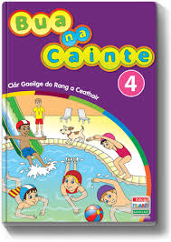
Irish/English dictionary  Dictionary will be used by your child until 6th class | 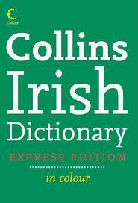
SPHE
Weaving Well-Being - 4th Class - Tools of Resilience - Pupil Book  Publisher: Outside the Box | 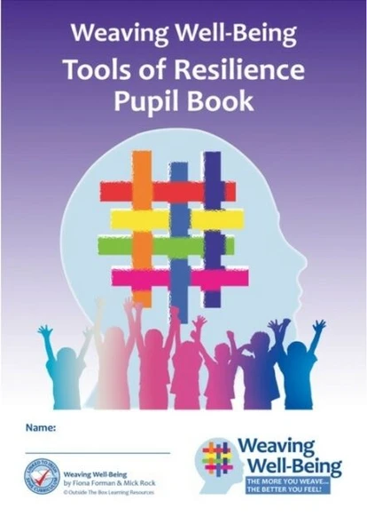
Copies and other
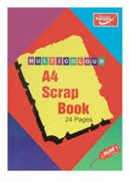
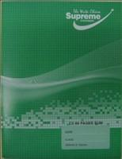
2 x Maths Copies (7mm 88pg) 4 x Exercise Copies (88pg) 1 x A4 Scrap Book

(Copies for: English, Gaeilge,
Free Writing, Homework)

2 x A4 Maunscript copies 1 x Note Book (120pg) 2 x Nature Study Copy (32pg)

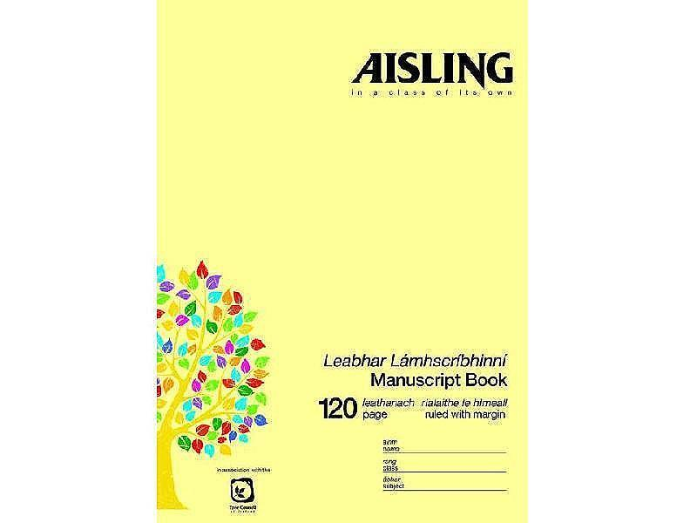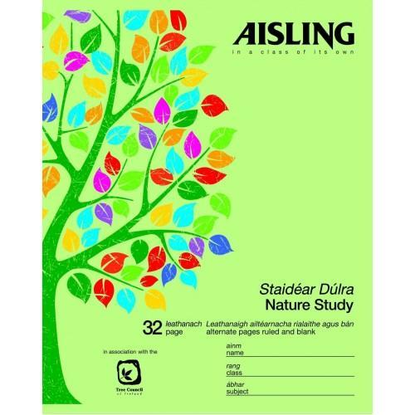

(Copies for SESE)

1 x Handwriting
Learn and Write B4

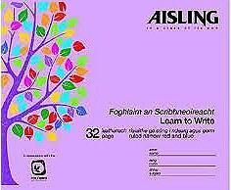

Fallon’s Homework Diary
Please note that this is the only homework diary that may be used this year.
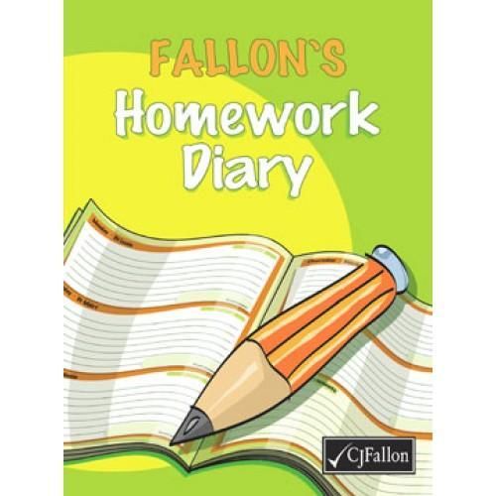

Geometry set Digital calculator Tinwhistle (D)
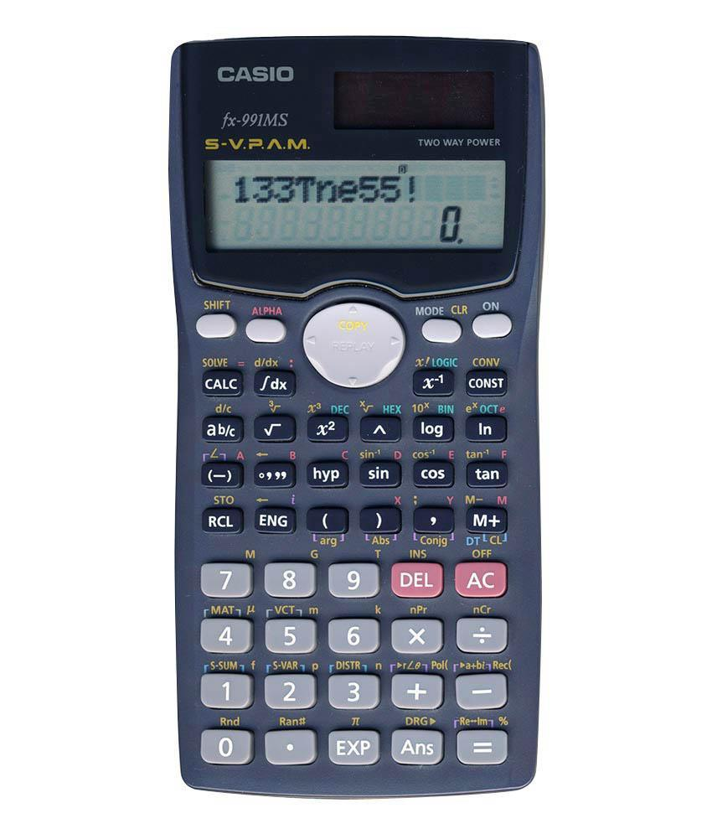
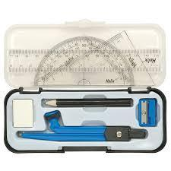
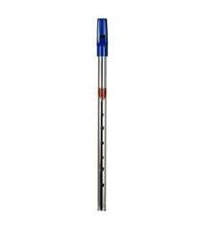

Copies and Stationary
- 2 x Maths copies (7mm squares 88 pages)
- 4 x Copybooks (88 pages)
- 2 x Nature Study copies (32pg)
- 1 x Handwriting copy. Learn and Write B4 (32 pages)
- 1 x Notebook for spellings (120pg)
- 2 x Manuscript A4 copies
- 1 x A4 Scrapbook
- Fallon’s Homework Diary
- Digital calculator
- D Tin whistle
- Geometry set
Please ensure that your child has each of the following at all times throughout the year:

4 x HB Pencils, Red ballpoint pen, Blue ballpoint pens, Pencil sharpener, Rubber,
30cm ruler and 15cm ruler, Colouring pencils or twistables (NO MARKERS),
4 x large Pritt Sticks,
5 x mini-whiteboard markers (bullet tip),
A4 (mesh type) homework folder (pouch with zip),
Pencil case

Parents/Guardians must purchase all text book and the correct copies and stationary items.
Please cover all books and copies and put your child’s name on them.
Please ensure that your child has all of the above on the first day of school as school texts will not be photocopied
Please ensure each item of stationary is clearly labelled with your child’s name.
The school will NOT provide replacement pencils, copies, paper, rubbers, markers, Pritt Sticks for your child during the school year. Parents must replace these items.
All class booklists will be available on the school website: www.scoilchormaiccns.ie

Photographs of the books & copies & stationary are available on the school website & on the noticeboard.

The two bookshops in Balbriggan have been provided with a copy of the school booklists.

