Third Class Booklist 2020/2021
English
Word Wizard 3rd Class  Gill Education | 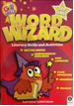
Go with the Flow Handwriting Book E  CJ Fallon | 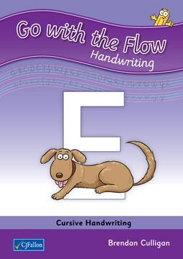
Collins Pocket English Dictionary & Thesaurus  Collins  Dictionary will be used by your child until 6th class | 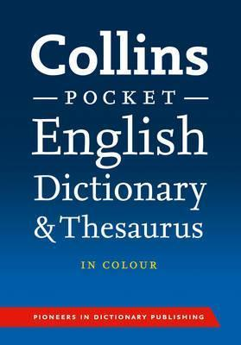
Maths
Operation Maths - Discovery Book 3, Assessment Book 3, Mini whiteboard and Place Value Card  Do not buy the Operation Maths Pupils’ Book as the school already has a copy for your child.  Edco | 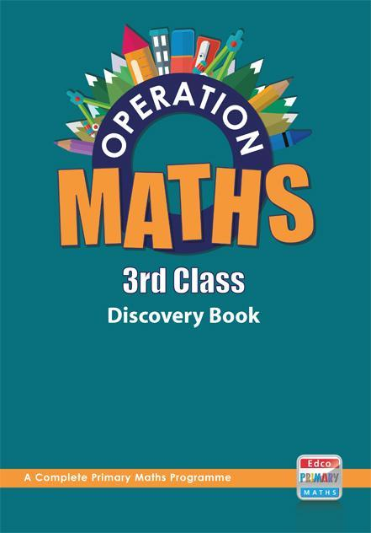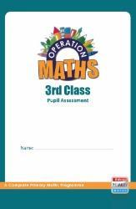
Maths Time 3  Edco | 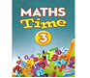
Table Champions for Third Class  Educate.ie | 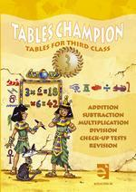

Gaeilge
Bua na Cainte 3  Edco | 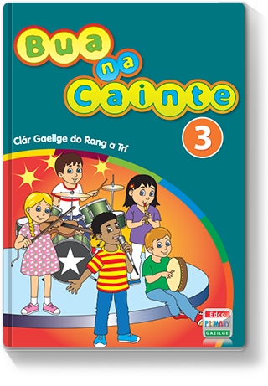
SPHE
Weaving Well-Being - 3rd Class - Positive Emotions - Pupil Book  Publisher: Outside the Box | 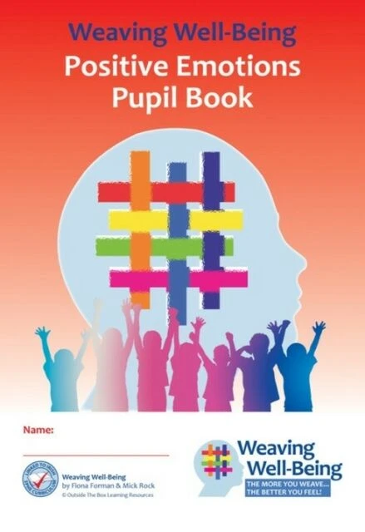
Copies and other
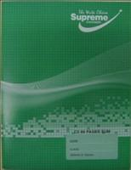
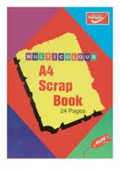
1 x Maths Copies (7mm 88pg) 5 x Exercise Copies (88pg) 1 x A4 Scrap Book

(Copies for: English, Gaeilge,
Free Writing, Homework)

1 x A4 Maunscript copies 1 x Note Book (120pg) 1 x A4 Hardback

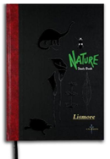
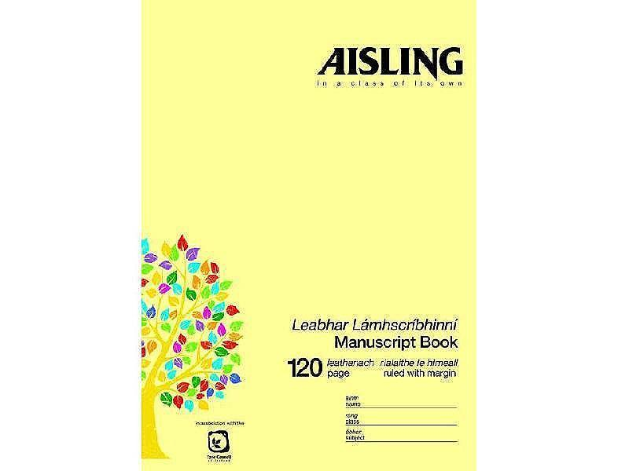

(Copies for SESE)

1 x Handwriting Tinwhistle (D)
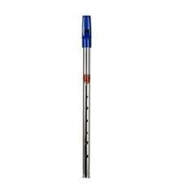
Learn and Write B4

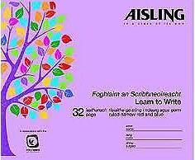

Fallon’s Homework Diary
Please note that this is the only homework diary that may be used this year.
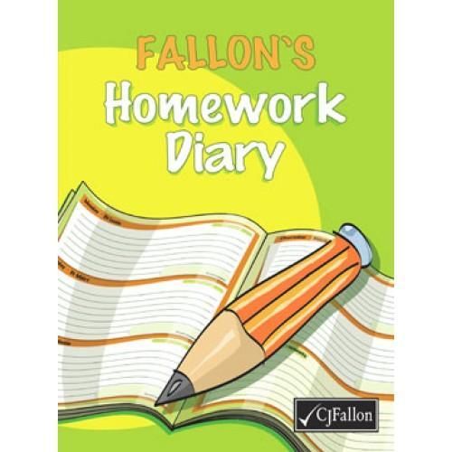

Copies and Stationary
- 1 x Maths copies (7mm squares 88 pages)
- 5 x Copybooks (88 pages)
- 1 x A4 Nature Study Hardback Notebook
- 1 x Handwriting copy. Learn and Write B4 (32 pages)
- 1 x Notebook for spellings (120pg)
- 1 x Manuscript A4 copy
- 1 x A4 Scrapbook
- Fallon’s Homework Diary
- D Tin whistle

Please ensure that your child has each of the following at all times throughout the year:

4 x HB Pencils, | Colouring pencils | A4 (mesh type) homework folder
Red ballpoint pen, | (NO MARKERS), | (pouch with zip),
Pencil sharpener, | 4 x large Pritt Sticks, | Pencil case
Rubber, | 6 x mini-whiteboard markers | Plastic sandwich bag (Word
30cm ruler and 15cm ruler, | (bullet tip), | Study)

Parents/Guardians must purchase all text book and the correct copies and stationary items.
Please cover all books and copies and put your child’s name on them.
Please ensure that your child has all of the above on the first day of school as school texts will not be photocopied
Please ensure each item of stationary is clearly labelled with your child’s name.
The school will NOT provide replacement pencils, copies, paper, rubbers, markers, Pritt Sticks for your child during the school year. Parents must replace these items.
All class booklists will be available on the school website: www.scoilchormaiccns.ie

Photographs of the books & copies & stationary are available on the school website & on the noticeboard.

The two bookshops in Balbriggan have been provided with a copy of the school booklists.

