Maths Week with Mr. Dowling’s 2nd Class!

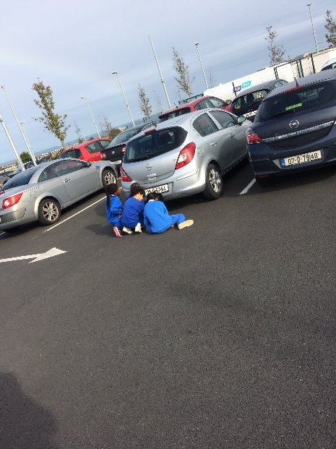 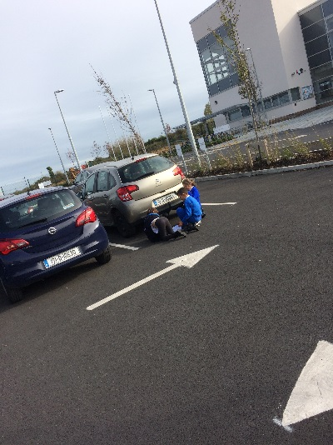

During Maths Week we completed a Maths Trail which took us all over the school building.

There were 6 groups and each of these were made up of writers, measurers, photographers and time keepers.

Our trail focused on our topics of Number, Comparing, Ordering and Pattern.

The children had a ball completing the activity and for many they enjoyed completing word problems based on real-life situations!

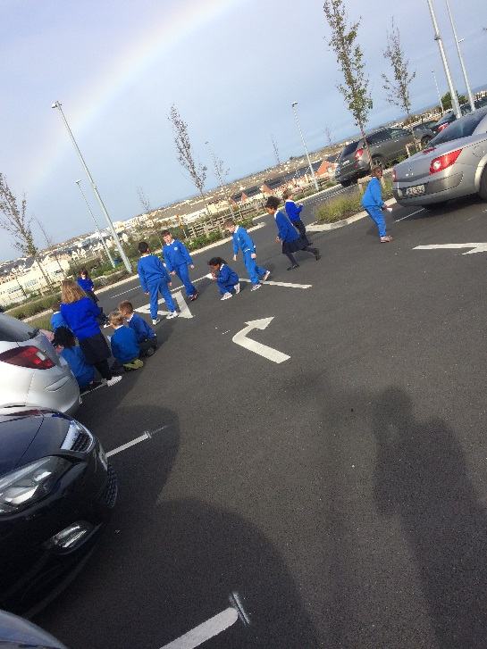

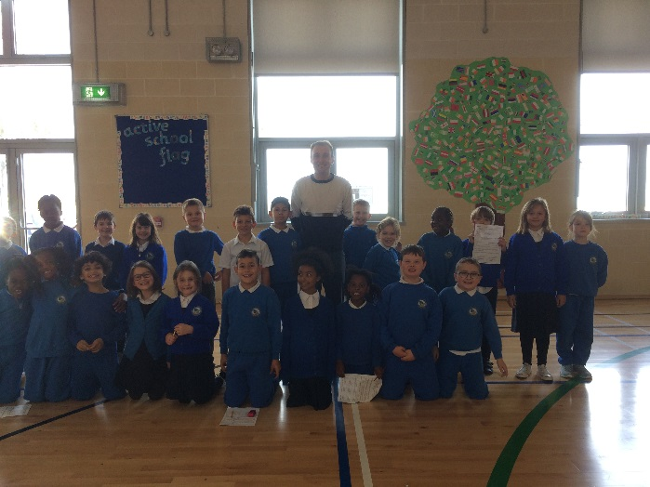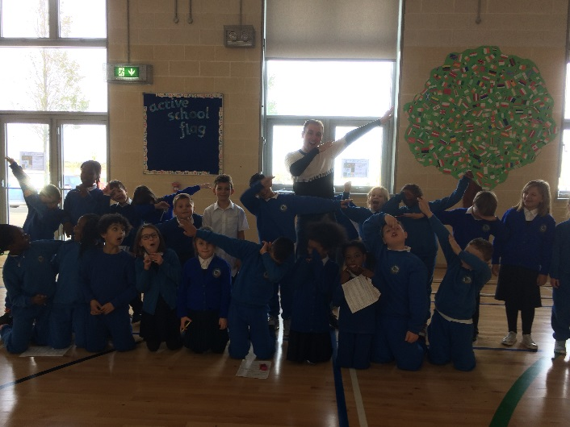

When we finished the Maths Trail we went to the hall and took two selfies to mark our successful completion!!

Can you guess which selfie we enjoyed doing the most?

Well done guys ☺