Sixth Class Booklist 2017/2018
English
All Write Now Level D Cursive  Edco | 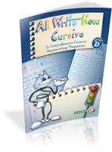
Literacy Leap 6th Class  Folens | 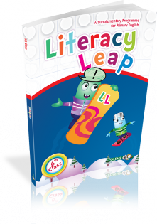
Collins Pocket English Dictionary & Thesaurus  Collins | 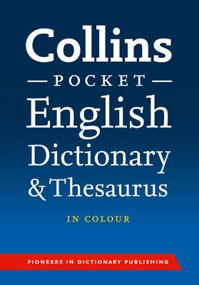
Maths
Planet Maths 6th Class  Folens | 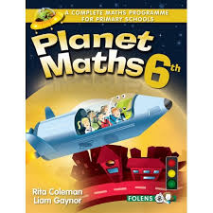
Maths Time 6  Edco | 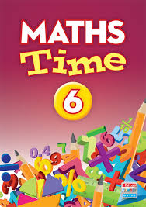
Table Champions for Sixth Class  Educate.ie | 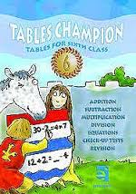

Gaeilge
Béal Beo 5  Edco | 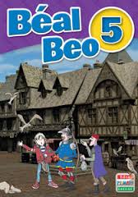
Any Irish/English dictionary | 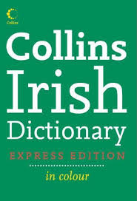
Copies and other
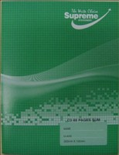
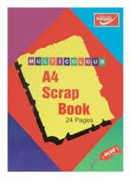
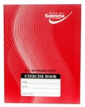
2 x Maths Copies (or similar) 10 x Exercise Copies (or similar) 1 x A4 Scrap Book (or similar)

1 x Note Book (or similar) 1 x A4 Refill Pad (or similar) 1 x Ring Binder-any colour
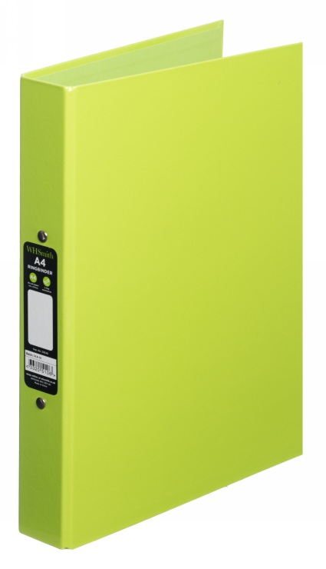
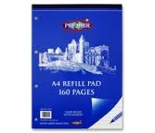
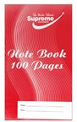

Fallon’s Homework Diary
Please note that this is the only homework diary that may be used this year.
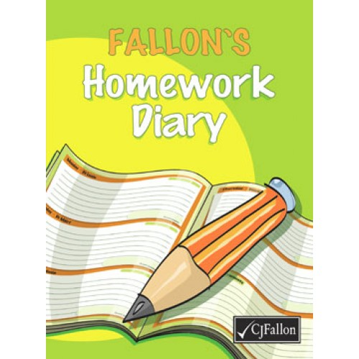

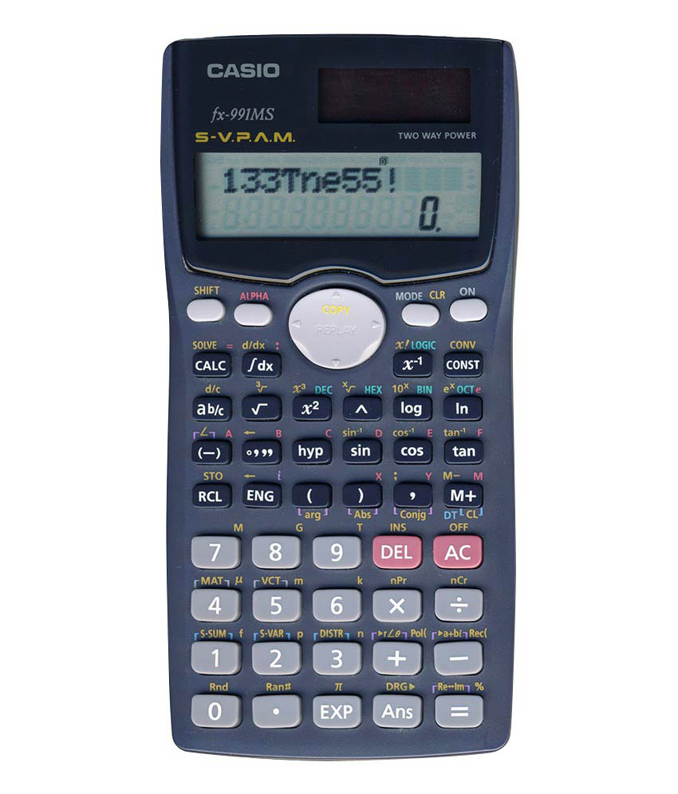
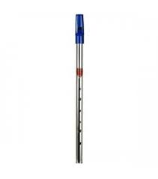
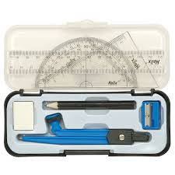
Math set Digital calculator Tinwhitsle (D)

ENGLISH –
- All Write Now Level D Cursive Folens
- Literacy Leap 6th Class Folens
- Collins Pocket English Dictionary & Thesaurus Collins
(Dictionary will be used by your child until 6th Class)
MATHS –
- Planet Maths Sixth Class Folens
- Maths Time 6 Edco
- Table Champions for Sixth Class Educate.ie
GAEILGE –
- Béal Beo 5 Edco
- Irish/English dictionary
SESE –
- No textbook required
COPIES and STATIONARY
- 2 x Maths copies (smallest squares 88 pages)
- 10 x Copybooks (88 pages)
- 1 x Notebook for spellings
- 1 x A4 refill pad (160 pages)
- 1 x A4 Scrapbook
- Fallon’s Homework Diary
- Digital calculator
- D Tin whistle
- Maths set

Please ensure that your child has each of the following at all times throughout the year:

4 x HB Pencils,
Pencil sharpener,
Rubber,
30cm ruler,
Colouring pencils (NO MARKERS),
4 x large Pritt Sticks,
5 x mini-whiteboard markers,
1 x mini-whiteboard
Homework folder (pouch with zip),
Pencil case

Parents/Guardians must purchase all text book and the correct copies and stationary items.
Please cover all books and copies and put your child’s name on them.
Please ensure that your child has all of the above on the first day of school as school texts will not be photocopied
Please ensure each item of stationary is clearly labelled with your child’s name.
The school will NOT provide replacement pencils, copies, paper, rubbers, markers, Pritt Sticks for your child during the school year. Parents must replace these items.
All class booklists will be available on the school website: www.scoilchormaiccns.ie

Photographs of the books & copies & stationary are available on the school website & on the noticeboard.

The two bookshops in Balbriggan have been provided with a copy of the school booklists.

